

Internal Memorandum

**To:** CIO

**CC:**

**From:** Hunter Meloche

**Date:** Oct 21, 2018

**Memo #:**

**Re:**

Inject 3

Dear CIO,

This rule blocks SSH from 192.168.60.6 from the host machine.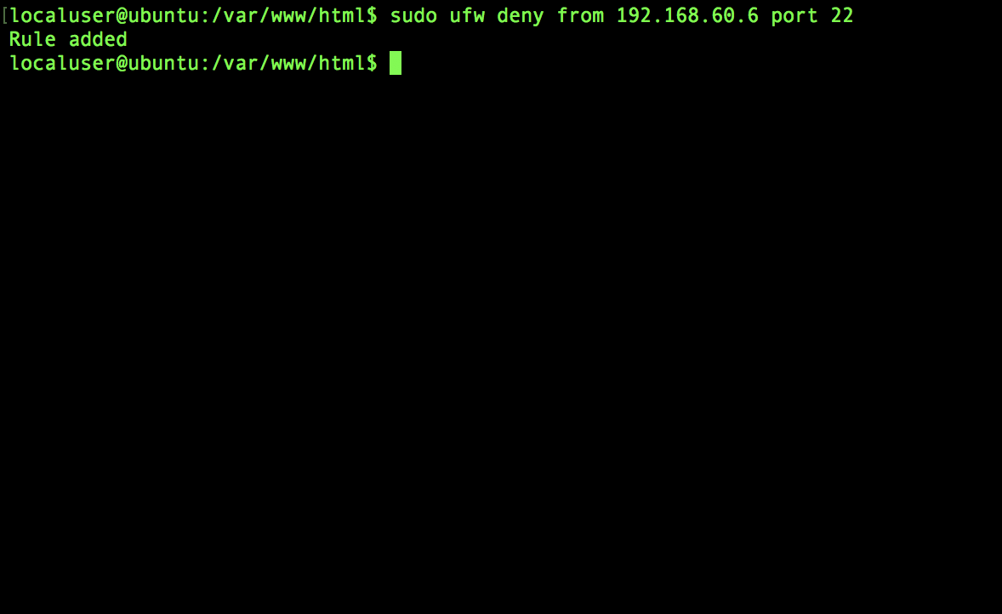

Sincerely,

Team A

*In accordance with HAL Memorandum policy, the entire header must be completed or the recipient may not acknowledge this as an official memorandum. Professional communications methods and decorum must be observed at all times.*